8.15.26 Website Review
https://cablelink-design.vercel.app/cablelink_modern_v2.html#home

- Pop-up
  - Privacy Notice
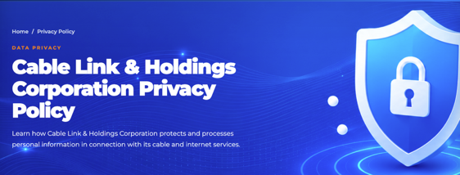
- Instead of full corp name, just use “Cablelink Privacy Policy”, considering the succeeding phrase indicates the full company name.
- Alignment: CABLELINK
Privacy Policy

  - Like us on Facebook
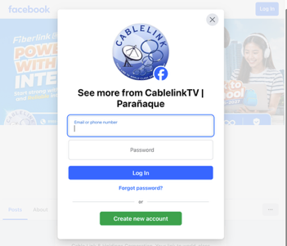 Clarification on “Paranaque”; is this geo-specific based on our address or “visitors” location. Or default? If this can still be modified, better to remove as it “limiting”, or will impressed upon visitors that we are only in “Paranaque”. Considering that we cover more areas than just Paranaque.

- Main Page
  - Header
    - HOME
    - SERVICES
    - Promos
    - Payment Facilities
    - Support
    - Advisories
    - Contact Us
    - Search Icon
    - Get Connected
    - My Link
  - Get Started
  - View Plans
- Scroll down
- Banners – not clickable to divert to another page *best if it can, when applicable
- Promo Carousel
  - See all Promo – jump to Promo page - okay
- Watch our Commercial
  - Clickable and plays - okay

- Footer
  - Ready to Get Connected
 - edit Cable Link to Cablelink

Note: When to use Cable Link and Cablelink?
Cablelink (1 word) is the Trademark, so we use it for Marketing related materials (websites use), modify all CableLink; while
Cable Link (2 words) when we refer to the company or the corporate entity.

  - 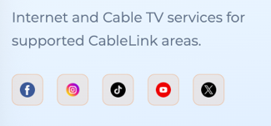 I don’t get the phrase above the socmed icons; please clarify
  - Services
    - Internet Plans – redirection okay
    - Cable TV Packages – redirection okay
    - Plans & Pricing – redirection okay
    - Enterprise - see enterprise related notes
  - Company
    - About Us – subject to modification – additional materials will be provided
    - Careers – redirection okay
    - Contact Us – redirection okay
    - Privacy Notice - okay
    - Get in Touch - okay
      - Phone – (click-to-call or Tap2call: will soon be available)
      - Email – clickable - okay
      - Service Areas – clickable – okay
    - Privacy Notice – okay
    - Terms of Use – okay

CONTACT US:
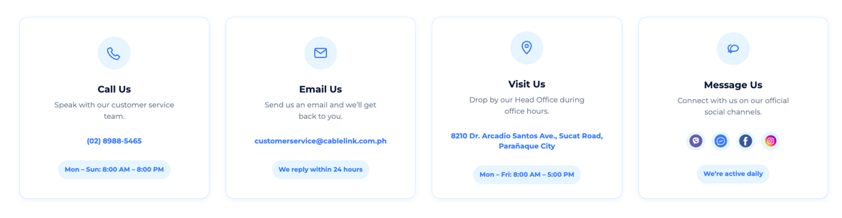
    - Call Us – (modify)
Live Support: Our Customer Service Representatives are available daily from 6:00 AM to 10:00 PM

    - Email Us - (modify)
Email Support: Send us an email anytime, and our team will respond during regular business hours.

    - Visit Us – (modify)
In-Person Assistance: Visit our office during regular business hours for personalized assistance.
      - Remove the head office address
      - Remove the day/time period as it varies
      - Since its clickable and jumps to payment center page

    - Message Us - (modify)
Message Us: Connect with us anytime through our social media channels.

  - Send us a message - okay

  - Support Center
We’re here to help with
- Account & Billing
- Internet connection troubleshooting
- Cable TV troubleshooting
- Services and Plans
- Need Immediate Assistance – landline (click-to-call or Tap2call: will soon be available)

  - Choose your audience
  - Residential
    - Get Connected – redirect to “Apply for Service”
    - Residential Support – redirected to Support “None-Subscriber FAQs”
  - Enterprise
    - Email Enterprise Sales – redirect to Email: sales@cablelink.com.ph
    - Enterprise Services – redirect to “Our services”
        - Best to show the Enterprise Service Catalog
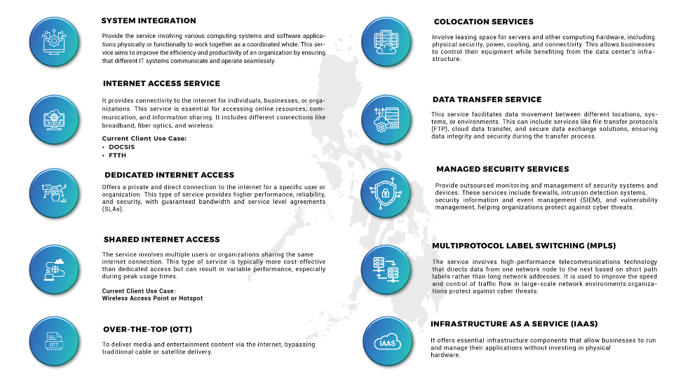
        - CTA is to email “sales@cablelink.com.ph”
        - Contact your Account Manager
        - For After Sales Support email to “enterprise@cablelink.com.ph”

SERVICES
- Dropdown
  - Internet
    - Explore
    - Supercharged
    - Turbocharged

  - Cable TV
“Standalone digital cable TV service. No Internet subscription required
    - Basic 495
        - 65 live channels
        - Analog (SD) Cable
        - No Internet Required
    - Basic Lite
        - 53 Live Channels
        - SD/HD CATV for digitally activated service areas
        - No Internet Required
    - Basic Plus
        - 126 Live Channels
        - SD/HD CATV for digitally activated service areas
        - No Internet Required

  - Enterprise
Talk To Us – redirect to Contact Us:

SERVICES (page)
- Residential Internet – redirect Plans & Pricing (price menu)
- Cable TV – redirect to channel line-up
- Bundled Plans – redirect to package meu
- Enterprise – redirect to contact us
      - Modify and redirect to Enterprise Services

- Start Today

GET CONNECTED – redirected to “Service Availability”
    - Iblaze (Cable Internet) / Fiberlink (Fiber Internet)
- 5-Steps (fillable)
- Service
- Plan
- Personal Information
- Address
- Review Application
        - Supporting documents - choose file to attached
          - Submit will not enable without attaching required document
        - Enable “submit application, only when TOS and PP are checked
- Need help choosing
        - Explore Services – redirect to SERVICES
        - Chat with Us – redirect to Message Us: Connect with us anytime through our social media channels.
        - Sales FAQs - redirected to Support “None-Subscriber FAQs”
        - Contact Us - redirect to Contact Us:

Plans & Pricing
  - In clickable thumbnail – redirect to Get Connected

Promo (page)
- Browse All promo – redirect to promo thumbnails
- View Plans – redirect to Plans & Pricing
- Get Connected - redirected to “Service Availability”

Payment Facilities
- Accredited Partners
- Walk-in Payments – directed to “Payment Centers”
Prefer paying in person? Our offices are open to assist you with billing and payments.
- View Cablelink Offices – jump to payment centers
- Auto Debit Arrangement
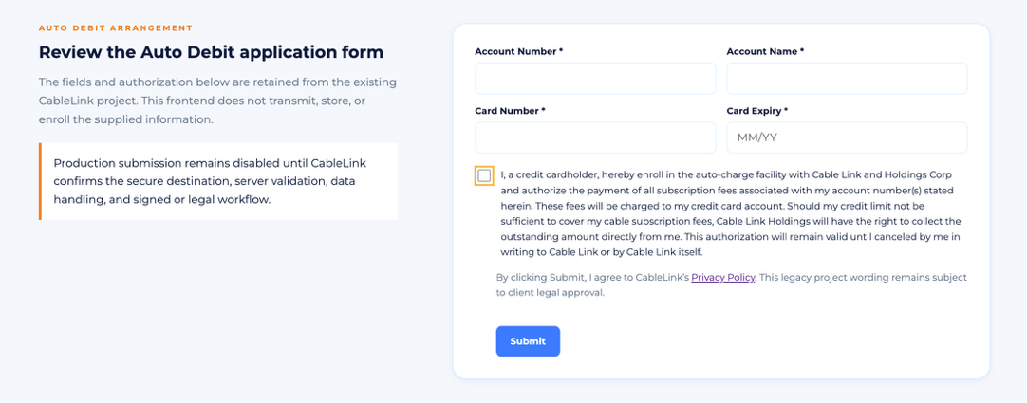
**Subject to Finance Review and confirmation
- Helpful Reminder
    - General Payment Reminders
- View Billing FAQs – redirect to “Support” page
- Need Help with your bill?

SUPPORT
- Drop Down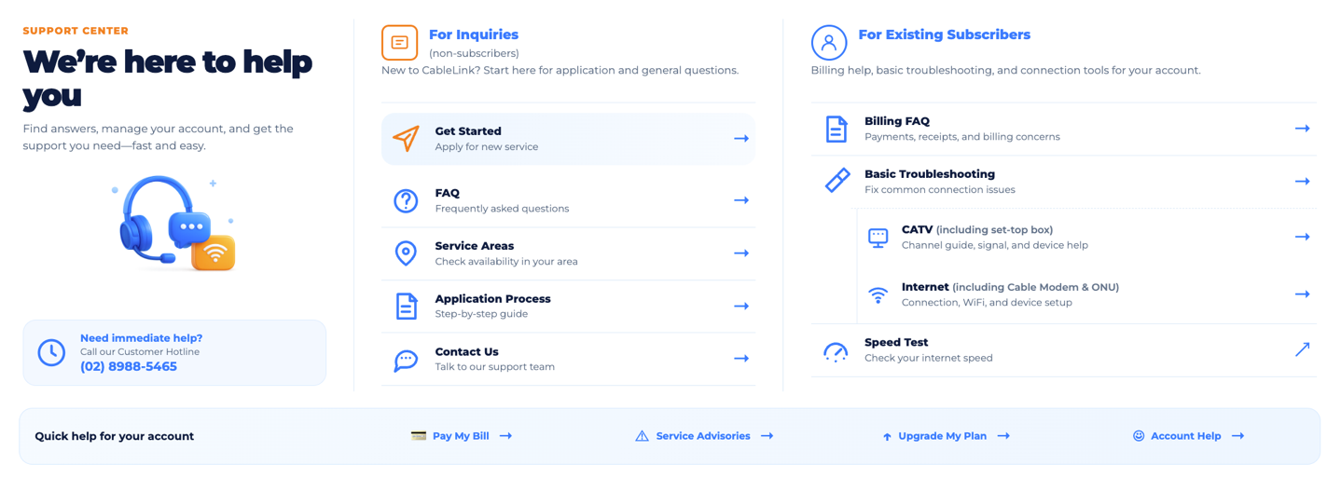
  - Format – okay

ADVISORIES
  - Format – okay

Website Search
  - Format - okay

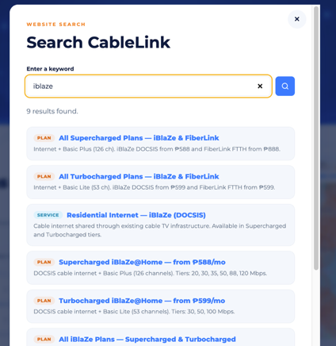

MY LINK
- link to follow

GET STARTED
- Redirected to SERVICES

VIEW PLANS
- Redirected to Plans & Pricing

